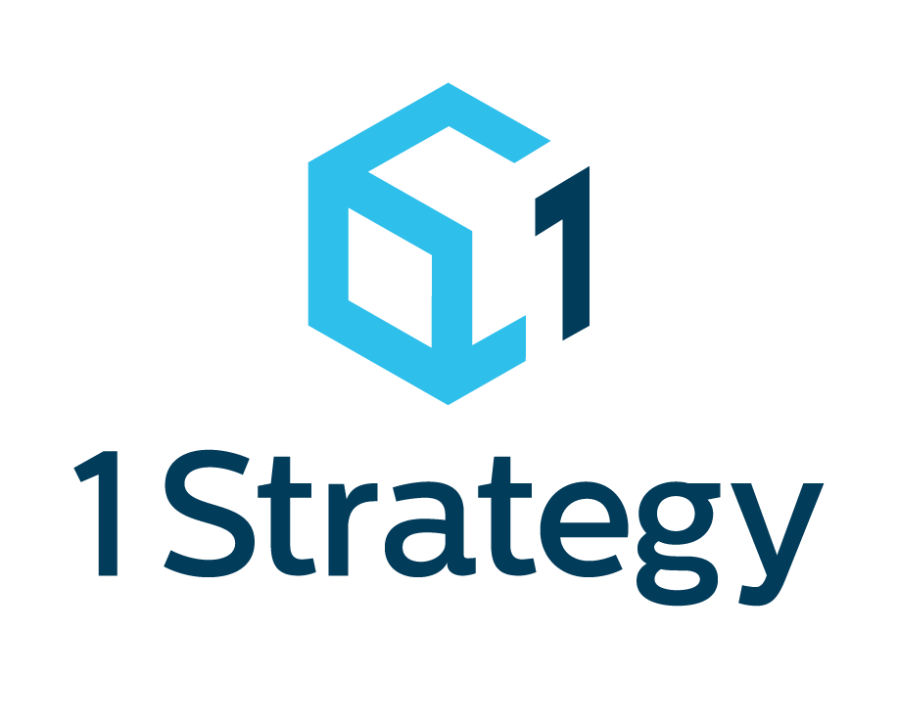

1Strategy ML Immersion Day

These are the work instructions that accompany the discussion of AWS ML capabilities and services.

Table of Contents

Purpose 1

Intended Audience 1

Hands-on Instructions 2

sagemaker 2

Concepts 2

Create a Notebook Instance 3

Prepared By 6

Company Information 6

# Purpose

The purpose of this training is to expose users to features of the AWS SageMaker service.

## Intended Audience

The intended trainees for this workshop are individuals interested in using machine learning techniques to train and deploy models on AWS. To be successful, attendees should have some understanding of, or experience with, the following:

* General AWS exposure
* S3
* IAM Permissions (Users, Roles, Policies)

Please note that in order to keep the pace of the material appropriate, several concepts may be glossed over given the expectation that the above topics are understood. For a cursory exploration in any of the above areas, please visit: https://amazon.quicklabs.com to find several free and paid training labs.

# Hands-on Instructions

This hands-on portion is a single, short workshop. It provides an introduction to AWS services covered in the presentation material.

## sagemaker

### Concepts

**handler_name**(event, context):

The **handler** is the “main” function that will be run when the lambda function is invoked.

<http://docs.aws.amazon.com/lambda/latest/dg/python-programming-model-handler-types.html>

handler_name(**event**, context):

The **event** object– AWS Lambda uses this parameter to pass in event data to the handler. This parameter is usually of the Python **dict** type. It can also be list, **str**, **int**, **float**, or **NoneType** type.

<http://docs.aws.amazon.com/lambda/latest/dg/python-programming-model-handler-types.html>

handler_name(event, **context**):

The **context** object – AWS Lambda uses this parameter to provide runtime information to your handler.

<http://docs.aws.amazon.com/lambda/latest/dg/python-context-object.html>

### Create a Notebook Instance

1. From the AWS Console home page, you can search for the SageMaker service.

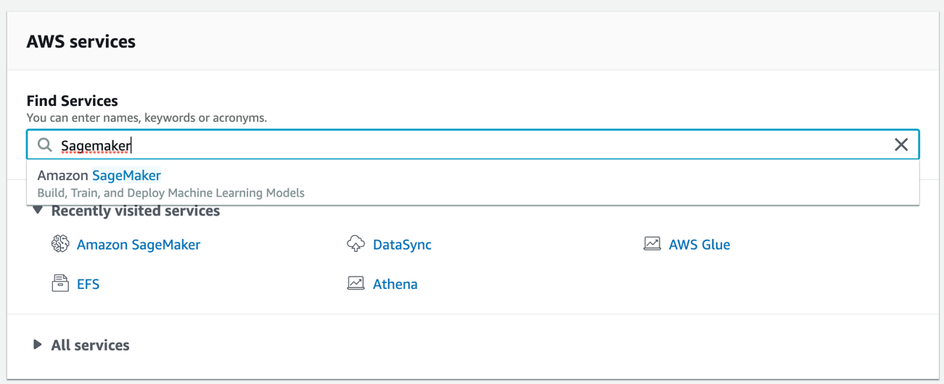

1. The SageMaker Dashboard provides four options. Click the **Notebook Instances** button.

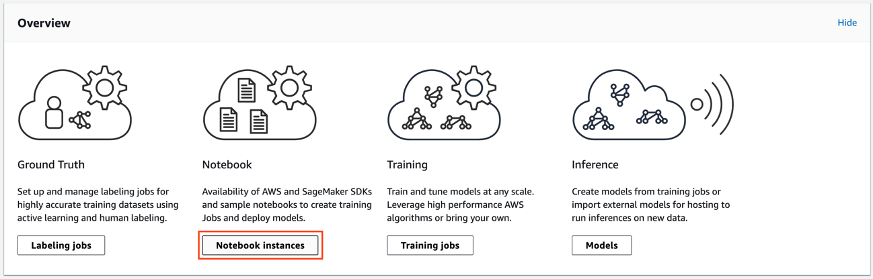

1. On the next page, select **Create notebook instance** in the orange box.

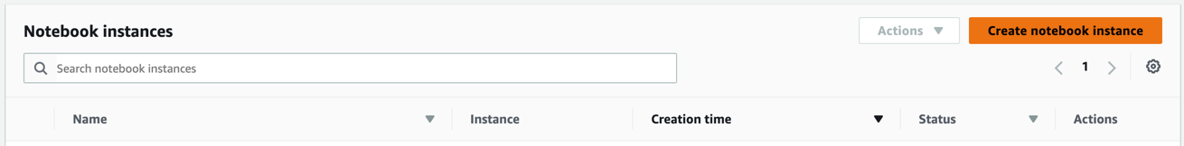

1. Enter <**YOUR NAME>-notebook** as the name of the notebook.
2. The instance type should remain **ml.t2.medium** and the Elastic inference option should show **none**.
3. Choose the generic **AmazonSageMaker-ExecutionRole** that appears in the IAM Role drop down menu.
4. Under **Git repositories**, choose *Clone a public Git repository to this notebook instance only* from the drop-down menu. You should now be able to type the public repo URL for this workshop in the available text box. Your **Git repository** settings should look like this:

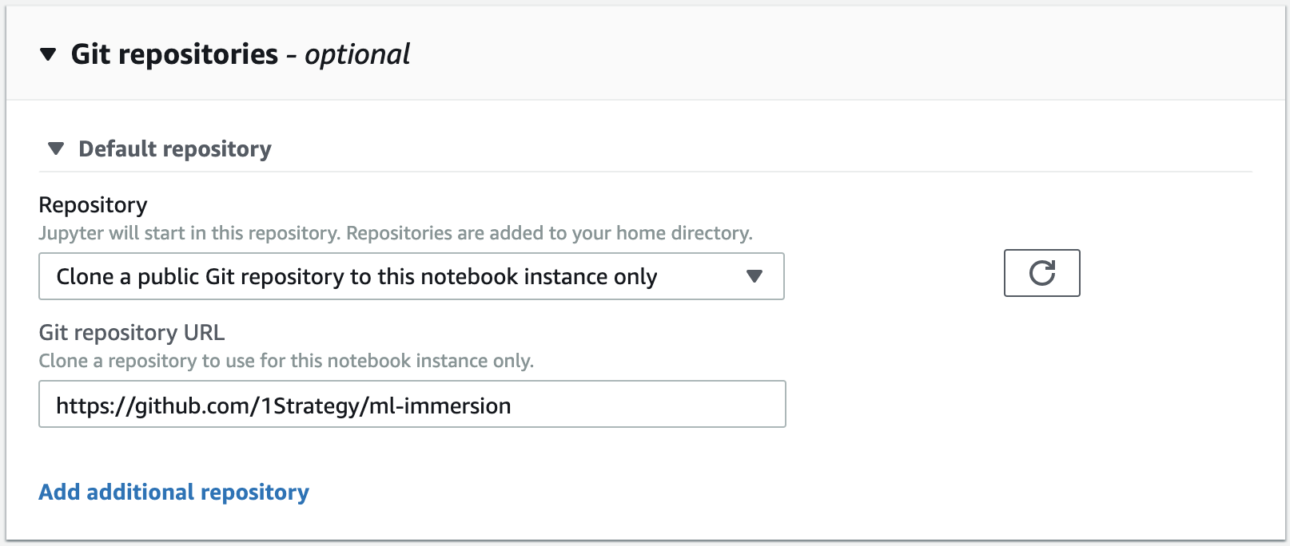

1. Finally, click **Create notebook instance** in the lower right corner of the page.
2. Your notebook instance should be provisioning. After several minutes, you will see your notebook status change to the **InService** state.



1. Select **Open Jupyter** to begin working in the notebook.
2. For this lab, we have instructed the notebook instance to clone our public code repository, but the service also supports cloning into privately hosted repos. The root directory of your Jupyter notebook should look like the image below.

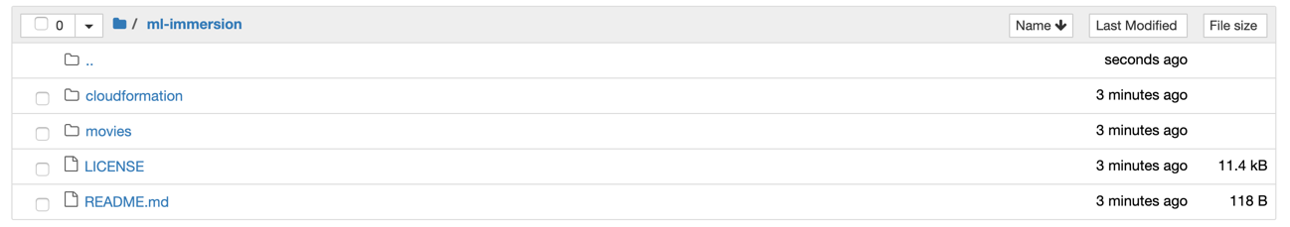

If you don’t see the **cloudformation** directory or the **movies** directory, you may have setup your notebook incorrectly.

1. Click into the **movies** directory. From there you should see a file named **movies_logistic_regression.ipynb**. Click this file. It should open in a new browser tab and you will be able to begin working through the notebook.
2. Execute each cell in the notebook in order. The entire lab should only take around 15 minutes to complete. If you have trouble with anything, please let the instructor know.

END OF WORKSHOP

Feel free to help those around you if you finish early.

# Prepared By



|  |  |  |
| --- | --- | --- |
| Alex Graves  Principal Cloud architect - Data |  |  |
|  |  |  |
| alex@1strategy.com |  |

# Company Information

1Strategy

3025 112th Ave SE #200

Bellevue, WA 98004

www.1strategy.com